Computer Science Assesment
My Project
I am making a bank budgeting app. It works locally on the device, so there is less security risk. The user uploads the Excel file of their bank statement, and the program then gives a breakdown of their spending. It also has accessibility features such asdark mode, and possibly currency and language options.

High fediatly design using figma AI.
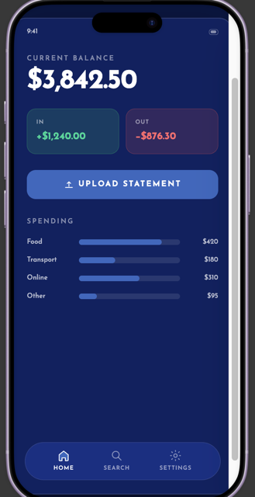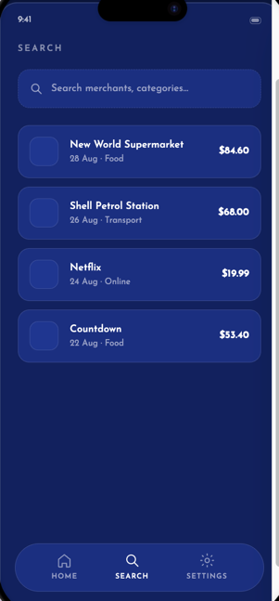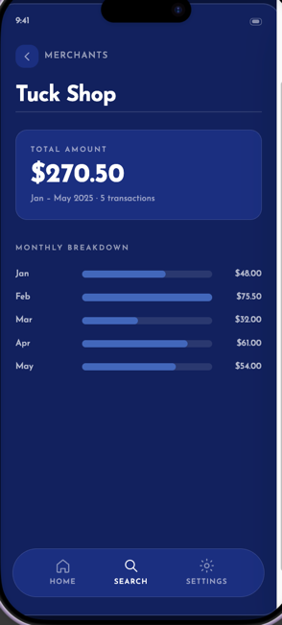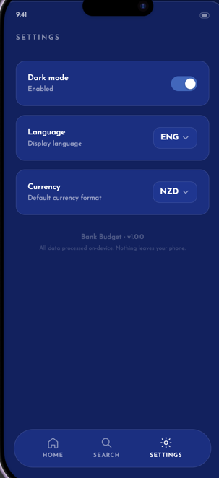

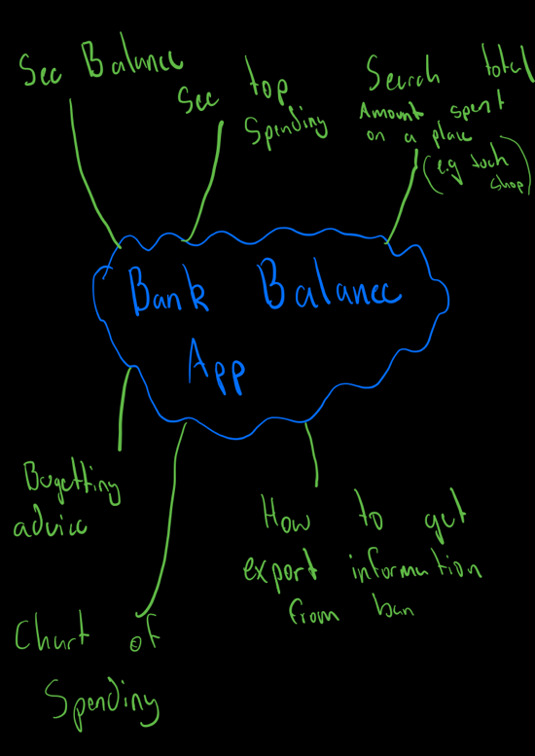
Planning

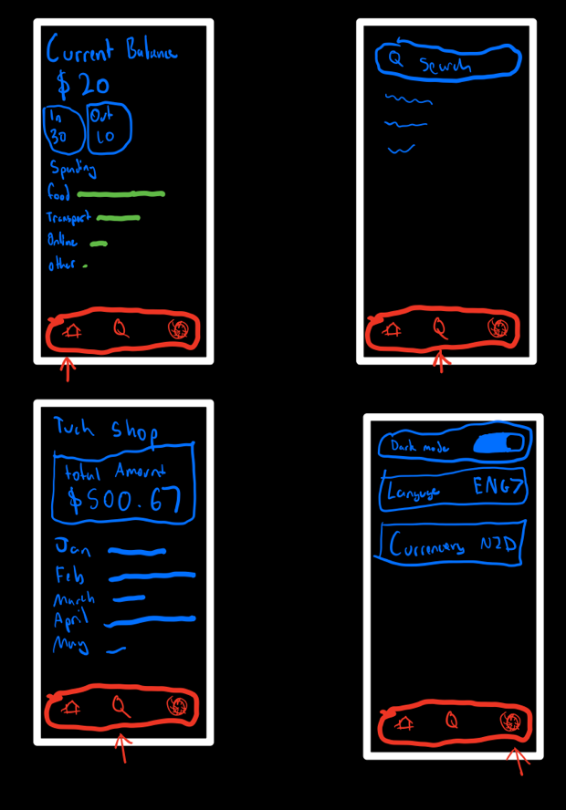
Wire frame

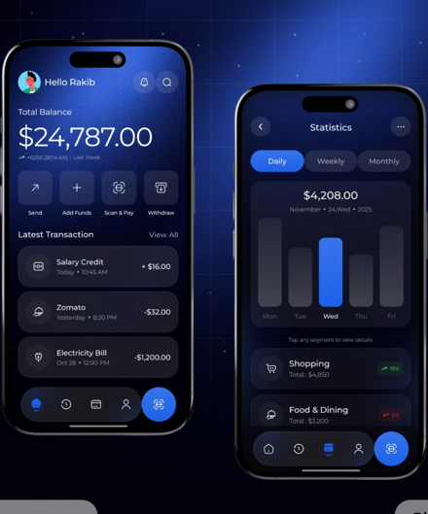
Colour and Font
Loved the theme on this app so I might take some I inspiration.
Colour Pallet for the website

Font is from Google Fonts

Two Advance Techcqies
-Media Queries
- CVS using

Getting Started

I have all of this from what we did in class and before I changed my idea, I would still like to use the mobile Menu form UI verse (Mobile Menu). However, I will have to change the colour theme. The font could potienally stay
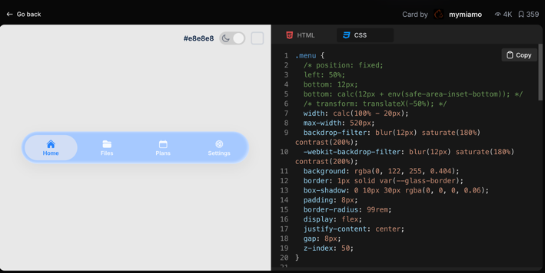
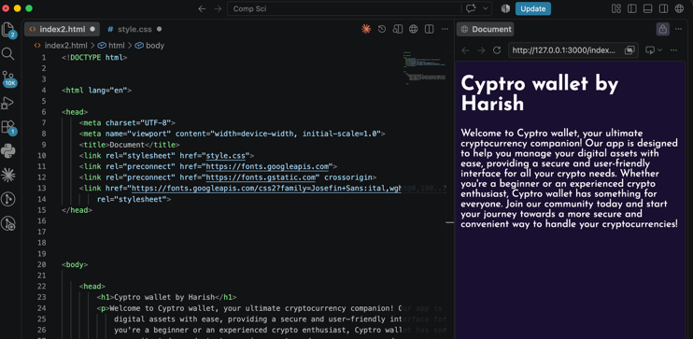

Mobile Menu (Navigation between menus)
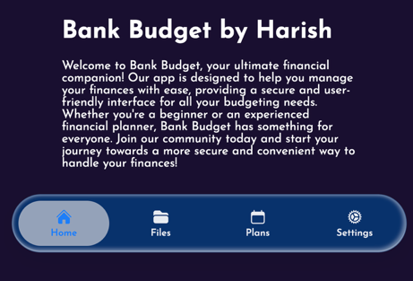
I added it on the website, but when I clicked the buttons, it did not take me anywhere. I put all four pages on one html file but put them in 4 sections

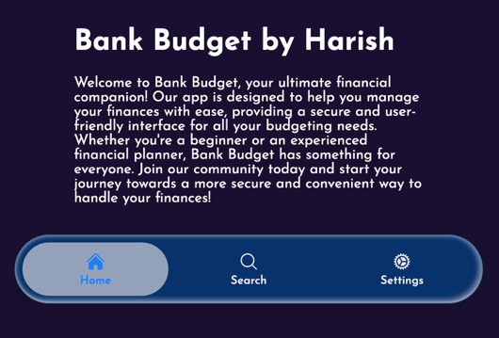
Icons and colour
I need to change the icons now to match what I had wanted in the wire frame. I got the magnifying glass form heroicons.com and just copy and pasted the SVG in and replaced it with files and deleted the plans, because I only needed 3 at the bottom.

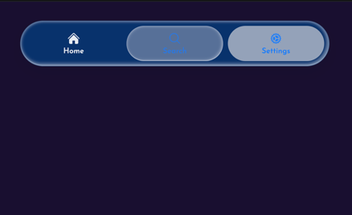
There is a bug this when I click the new search button it displays nothing and does actually show that you are in the page.

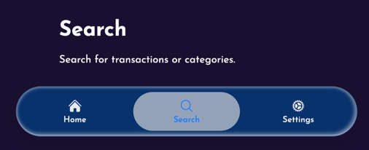
All I had to do was change the id for that section, form files to search, while I was there I also delted the section fo files as that wasn’t needed anymore. (However did make me think that later on a file section could be added to store the prevoise bank statements)
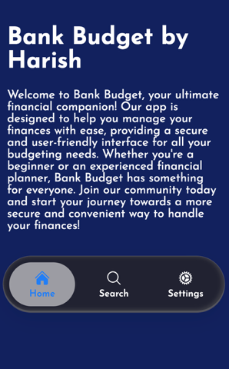
Changed the Colours of the app looking a lot more better now

Version Control (Git)
I installed the wrong Git for my project I had installed git lens, Not only that but it was trying to back up by whole computer instead of just the whole folder and could do it becaues it said (10k+) changes. I deiced to restart. Got it work on the 30/Aug where I had backed up what I had done.

Adding The CVS part
Frist I need to find a button on UIverse for me where the user can add there CVS

Adding the Parts to settings like the wire frame
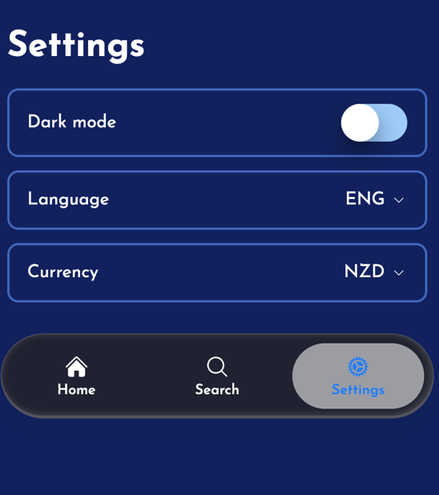
To align with the wireframe, I built the settings section using dedicated <div> rows. I used Flexbox specifically gap for uniform spacing and space-between to make the layout adapt responsively to any phone width. I used a toggle switch for dark mode, form UIverse. and used <select> tags for currency and language to manage long lists of options.

Advance Techniqe Number 1 media queries
Before adding media queries


Advance techinqe Number 2
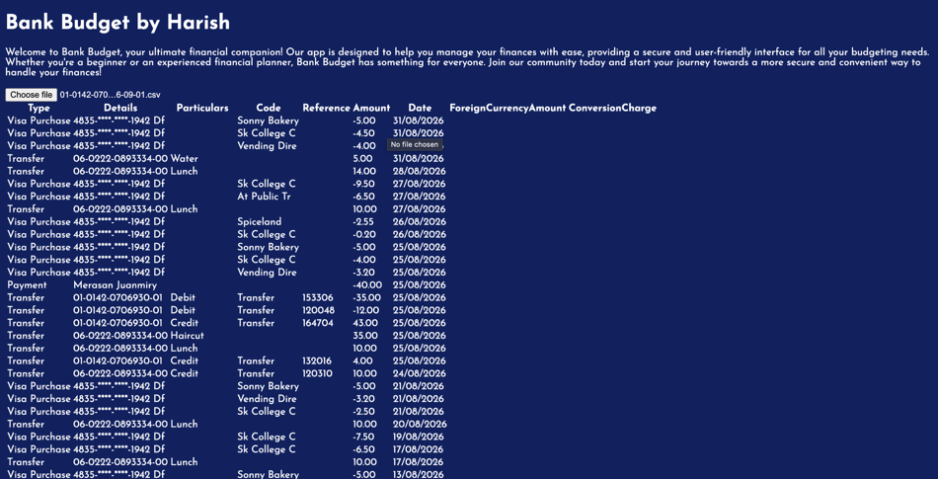
My second technies is CVS parsing
I am using Java scipt to read the file, following a toutioal on youtube I was able to get to this point .

However it looks unappling and I don’t thing there is much that can be done with this

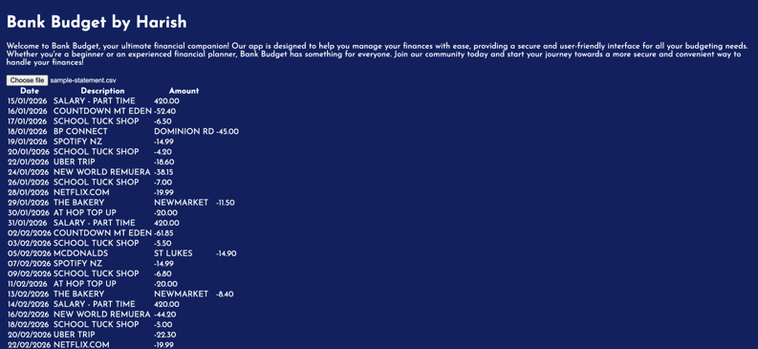
This is another issue

